Wave I.D. shows complete but part needs to be picked

**Purpose :-** Wave I.D. shows complete but we still have one part that needs to be picked. in the system.

Sample ticket for Reference – INC0881787

Description of ticket - Category : Software

Location : Branch: MESA, AZ WH.00143

Software: KORBER

Subcategory: Software behavior

On our OB load I.D. 25-14-ELPA-3-3, wave I.D. 25-14-ELPA-3-3-WS, we show a DW02964 GTY part still needing to be picked. However, when we try to scan into the wave I.D., it says it is complete. This will prevent us from shipping the load virtually.

Steps to follow to resolved this ticket

Check Load in Korber prod Application like below

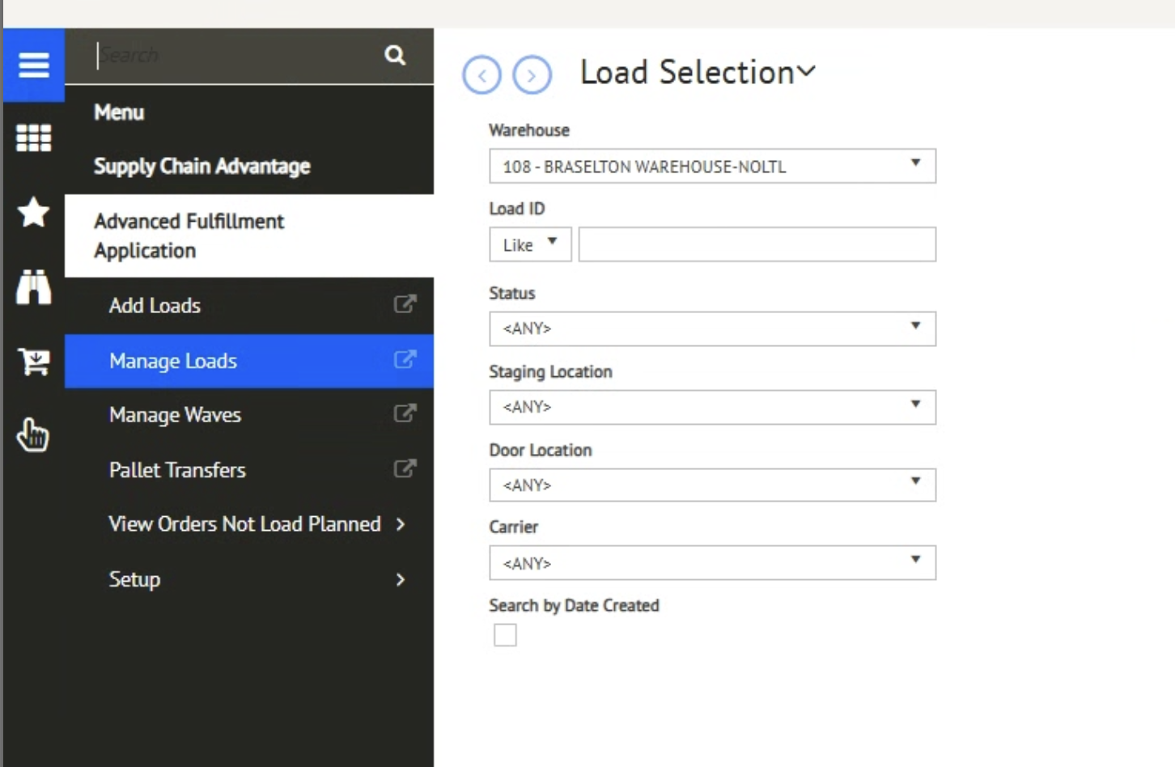

Select Ware house 143 and Load id 25-14-ELPA-3-3

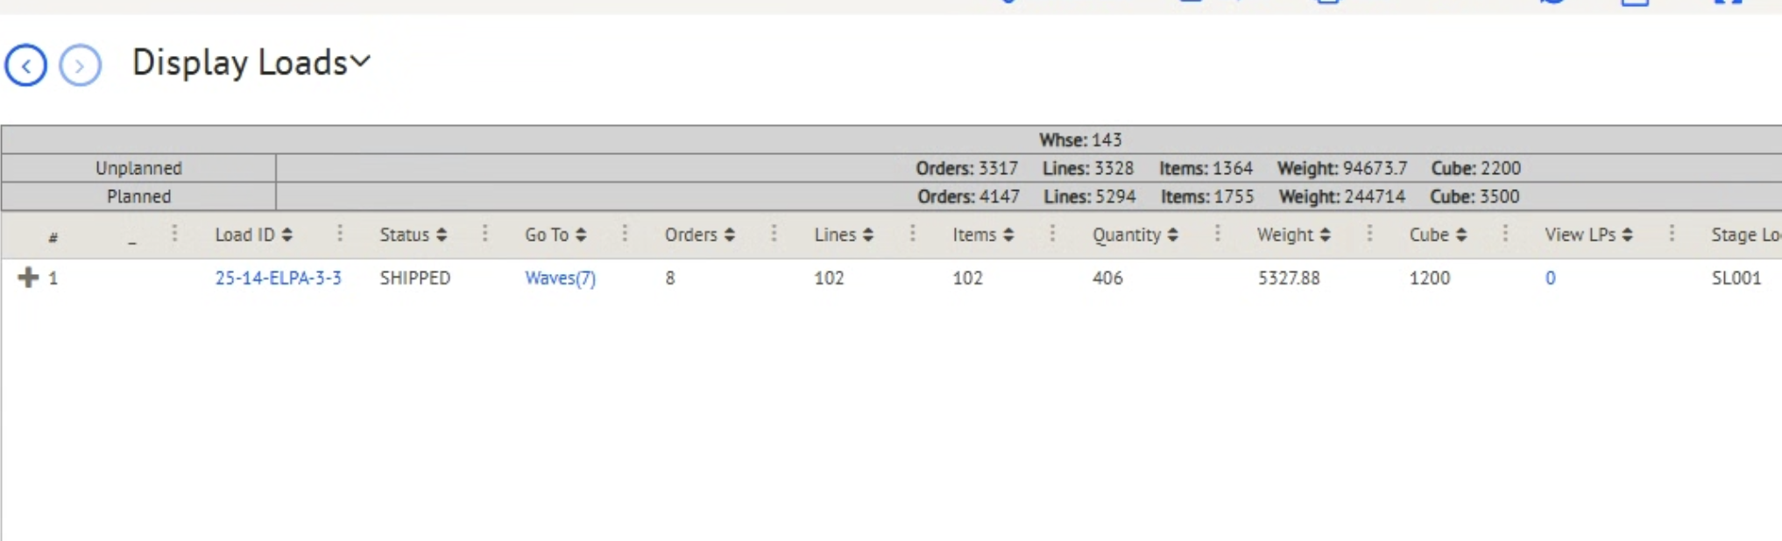

Check given item number in ESL data base and below result will be given



Here we can see the given Item number is cancelled so user can not picked it because it already shipped

**Conclusion- Since the load id has been already shipped so now user can not picked it. So ticket will be resolved from our end.**